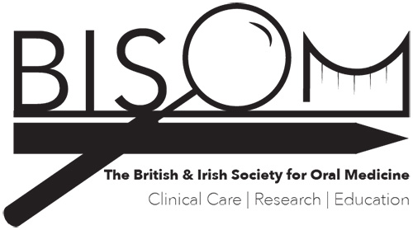

**British & Irish Society for Oral Medicine 2024 Research Grant Application Form**

* **Closing date: 1st November 2024**
* **The BISOM research grant will be for up to £10,000 and intended to support research related to the field of Oral Medicine. Applicants should be in early stages of a research career (e.g. pre-doctoral and not already undertaking a funded PhD), be working in any field of medicine or dentistry, but must be members in good standing of BISOM. On completion of their research project, successful applicants will be expected to present their research at a BISOM conference.**
* Please read the form carefully and ensure that all sections of the form are completed.
* Please complete and submit to:
  + The Secretary BISOM - **a.willis@qub.ac.uk**

|  |  |
| --- | --- |
| **SECTION 1: Your Personal and Contact Details** | |
| **Title:** |  |
| **Forename/s (in full):** |  |
| **Surname:** |  |
| **Home Address:** |  |
| **GDC/GMC/Irish Dental Council Number:** |  |
| **E-mail:** |  |
| **Telephone No:** |  |
| **Mobile No:** |  |
| **Specialty you are currently working in** |  |
| **Current Position (grade and employer/service setting):** |  |
| **Please confirm that you are a member of BISOM** | **YES  NO** |
| **Please confirm that you do not already have or are enrolled in a PhD or equivalent** | **Confirmed no PhD or equivalent** |

|  |  |  |
| --- | --- | --- |
| **SECTION 2: Primary Supervisor Details** | | |
| **Title:** |  | |
| **Name:** |  | |
| **Address:** |  | |
| **Telephone No:** |  | |
| **Email:** |  | |
| **Signature:** | | **Date:** |
| **By signing this form, the supervisor confirms that the Host institution can accommodate the applicant and that the terms and conditions including the financial arrangements can be met. The supervisor is advised to consult with the head of the institution and with the appropriate finance officer** | | |

|  |
| --- |
| **SECTION 3: Supervisor section: State your views on the candidate’s scientific ability and suitability to undertake this research, and on any other relevant points that you consider would be helpful to the society.** (No more than 200 words) |
|  |

|  |
| --- |
| **SECTION 4: Research training:** What training do you hope to gain and from whom? Please indicate why you wish to undertake a research project and how this will further your career (No more than 200 words) |
|  |

|  |
| --- |
| **SECTION 5: TITLE OF PROJECT** |
|  |

|  |
| --- |
| **SECTION 6: Research Plan (This should include the aim/objectives of the proposed research and details of the design/methods. Also include a brief timeline and indication of the likely costs). Do not exceed 1000 words.** |
|  |

|  |  |
| --- | --- |
| **SECTION 7: Applicant’s Declarations:** | |
| **If I am successful in obtaining this award, I agree to:**   1. Acknowledge the support of BISOM and include such wordings in all manuscripts. 2. Present the research at a BISOM conference | **YES**  **NO**  **YES  NO** |

|  |  |
| --- | --- |
| **APPLICANT’S SIGNATURE:** | **DATE:** |